OpenROAD VLSI Design - II
Kevin Umanzor
Talha Ibrahim
Giovani Giagnacovo
Githin Johny

Functional System Requirements

REVISION – 1
04 October 2025

Functional System Requirements
for
OpenROAD VLSI Design II

Prepared by:

Kevin, Talha, Githin, & Giovani 10/04/25
Author Date

Approved by:

Kevin Umanzor 10/04/25
Project Leader Date

_____________________________
John Lusher, P.E. Date

Hailey Ward 10/04/25
T/A Date

Change Record
Rev. | Date | Originator | Approvals | Description
0 | 09/30/25 | Kevin Umanzor  Talha Ibrahim  Giovani Giagnacovo  Githin Johny |  | Draft Release & Overview
1 | 10/4/25 | Kevin Umanzor  Talha Ibrahim  Giovani Giagnacovo  Githin Johny |  | Finalized for submission

Table of Contents
1. Introduction 6
1.1. Purpose and Scope 6
1.2. Responsibility and Change Authority 7
2. Applicable and Reference Documents 8
2.1. Applicable Documents 8
2.2. Reference Documents 8
2.3. Order of Precedence 8
3. Requirements 9
3.1. System Definition 9
3.2. Characteristics 10
3.2.1. Functional / Performance Requirements 10
3.2.2. Physical Characteristics 11
3.2.3. Electrical Characteristics 11-12
3.2.4. Environmental Requirements 12
3.2.5. Failure Propagation 12
4. Support Requirements 13
Appendix A: Acronyms and Abbreviations 14
Appendix B: Definition of Terms 15

List of Tables

No table of figures entries found.

List of Figures
Figure 1. Your Project Conceptual Image 1
Figure 2. Block Diagram of System 4

Introduction

Purpose and Scope

This specification defines the technical requirements for the development items and support subsystems delivered to the client for the project. Figure 1 shows a representative integration of the project in the proposed CONOPS. The verification requirements for the project are contained in a separate Verification and Validation Plan.

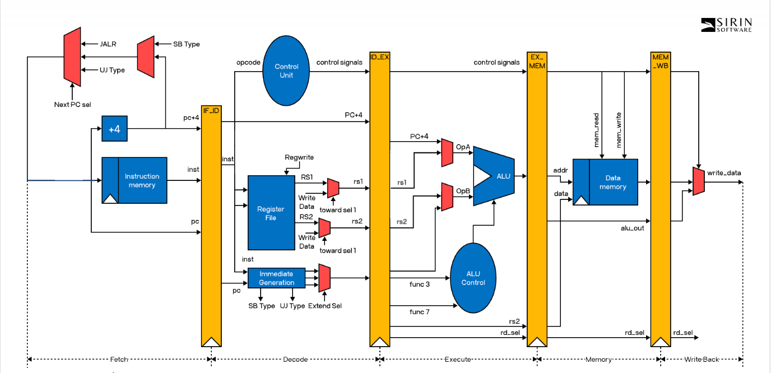

Figure 1. System Overview of 16-bit RISC-V

The following definitions differentiate between requirements and other statements.

Shall: This is the only verb used for the binding requirements.
Should/May: These verbs are used for stating non-mandatory goals.
Will: This verb is used for stating facts or declaration of purpose.

Responsibility and Change Authority

The team leader, Kevin Umanzor, is the one who is responsible for ensuring that the project is built within the constraints that have been given. When considering the authority to who is able to make changes to the project, those are given solely to the team leader along with Professor Kevin Nowka.

Applicable and Reference Documents

Applicable Documents

Document Number | Revision/Release Date | Document Title
UCB/EECS-2016-1 | 01/03/2016 | Design of the RISC-V Instruction Set Architecture

Reference Documents

The following documents are reference documents utilized in the development of this specification. These documents do not form a part of this specification and are not controlled by their reference herein.

Document Number | Revision/Release Date | Document Title
FIND | 2019 | The OpenROAD Project:  Unleashing Hardware Innovation

Order of Precedence
In the event of a conflict between the text of this specification and an applicable document cited herein, the text of this specification takes precedence without any exceptions.

All specifications, standards, exhibits, drawings or other documents that are invoked as “applicable” in this specification are incorporated as cited. All documents that are referred to within an applicable report are considered to be for guidance and information only, except ICDs that have their relevant documents considered to be incorporated as cited.

Requirements

System Definition

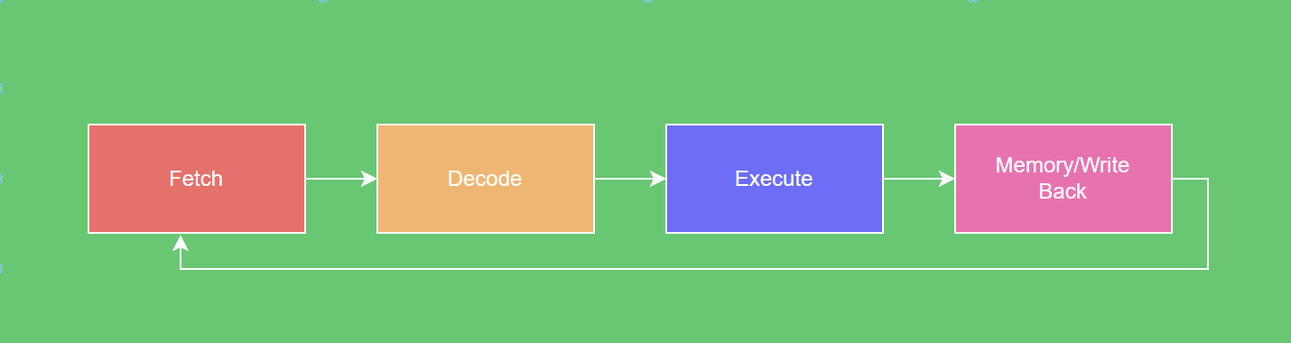

Figure 2. Block Diagram of System-

The block diagram provides a high-level, generalized view of the main subsystems of our 16-bit RISC-V processor. Instructions flow through four stages: Fetch, where the next instruction is retrieved from memory; Decode, where the instruction is interpreted and operands are read from the register file; Execute, where the ALU carries out arithmetic, logic, or branch operations; and Memory/Write Back, where results are written to memory or updated in the registers. These stages are interconnected in a pipeline, with control and data passed sequentially and feedback ensuring continuous program execution. This modular organization allows the processor to efficiently execute RISC-V instructions, providing a simple yet extensible foundation for building and testing a functional 16-bit CPU.

Beyond implementing the logic, building this 16-bit CPU also establishes the foundation needed to move into physical design. With a functioning core, we can use the OpenROAD flow to generate the complete GDSII layout, bridging the gap between abstract processor design and actual chip implementation. This process ensures that our project is not just about verifying instruction execution in simulation, but also about creating a working silicon-ready layout that integrates all stages of the design cycle, evaluating the use and efficiency of the OpenROAD tools along the way.

Characteristics

Functional / Performance Requirements

Instruction Set architecture (ISA) Support
This processor should abide by the core standards, conventions, and requirements of the RISC-V instruction set architecture. The processor will support instructions derived from the I32E embedded version of the RISC-V architecture.

Rationale: The choice to use the RISC-V ISA was made because it is an open, modular, and well-documented standard that provides flexibility for customization while ensuring compatibility with a widely adopted architecture.

Clock Frequency
The RISC-V processor should operate at a clock frequency of 10 MHz.

Rationale: The choice of a 10 MHz clock frequency was made to balance performance with ultra-low-power operation, ensuring the processor can execute instructions reliably without exceeding the strict power budget.

Datapath Width
The RISC-V processor that will be implemented will have the capability to support 16-bit instructions. These instructions will be based on the official RISC-V instruction set for an embedded processor.

Rationale: The choice of having 16-bit instructions was made because of the restriction of the 2-tile maximum layout and also considering the timeline for the project.

Register File
The RISC-V processor shall be able to support a system register file consisting of 16 general-purpose registers.

Rationale: Given the 16-bit instruction constraint, only 16 registers can be referenced directly in the opcode and instruction encoding, allowing for efficient use of all available bits per instruction while maintaining simplicity in the design.

Power Requirements
The RISC-V processor shall not exceed 200μW during active power consumption, remaining under this threshold during idle periods.

Rationale: The energy per instruction is expected to remain below 20 pJ/instruction, making the design suitable for lightweight, embedded, or educational applications where efficiency is critical and performance is not the highest priority.

Physical Characteristics

Tile-size constraint
The OpenROAD VLSI microprocessor shall occupy a maximum of 2 tiles on the Tiny Tapeout wafer provided by ChipFoundry.io. This maximum area is based on the simplicity of the processor design and lack of many additional components.

Rationale: This maximum area is defined by what should be necessary for a typical 16-bit RISC microprocessor design. This ensures that the chip does not occupy an unnecessarily large space.

Volume Envelope
The volume of the OpenROAD VLSI chip is expected to fall between 0.005 mm^3 - 0.04 mm^3.

Rationale: This maximum volume is defined by what should be necessary for a typical 16-bit RISC microprocessor design. This ensures that the chip does not occupy an unnecessarily large space.

Electrical Characteristics

Power Consumption
- The maximum power of the system shall not exceed 200μW.

Rationale: This is a requirement specified by our customer due to constraints of their system in which the Search and Rescue System is integrating.

Input Voltage Level
The input voltage for the RSIC-V 16 bit shall be +3.3V to +5.0V

Rationale: These requirements are specified by the skywater technology and their constraints for designing 130nm chips.

Outputs

I/O Pins
The OpenROAD VLSI microprocessor will include I/O pins for the I2C (inter-Integrated circuit) to connect to external I/O devices at a specified clock line. Additionally pins will be added for the SPI to ensure bytes are being properly sent/received by the external I/O device connected. A USB interface will also be provided for power and data transfer between other devices.

Rationale: These I/O pins are included to support the USB interface, I2C, and SPI interface requirements set for the microprocessor.

Environmental Requirements
The RISC-V 16-bit processor shall have Environmental Requirements specified in the following sections.

Thermal
The 16-bit fabricated chip shall operate in a temperature range from -55℃ to + 125℃.
Rationale: This is a requirement specified by the company that will fabricate the chip, Skywater Technologies.

Failure Propagation
The RISC-V 16-bit processor shall have failure propagations specified in the following sections.

      - Reset for Fault Recovery
The RISC-V 16-bit processor shall include a reset pin that allows the processor to recover from any unexpected states.

Rationale: The reset pin ensures the processor can be reliably returned to a known state after unexpected errors, improving system stability and ease of recovery.

      - ESD Protection
The RISC-V 16-bit processor shall include electrostatic discharge (ESD) protection diodes on all I/O pads to prevent internal damage caused by static discharge events.

Rationale: The ESD protection ensures that the internal logic of the processor remains unaffected by transient high-voltage events, preventing latch-up or permanent device failure and improving overall chip reliability.

Support Requirements
An overview of the implementation of the 16-bit RISC-V architecture shall be provided, including the design details, which was built keeping in mind the 16-bit size, Verilog code & testbenches for each major component, and the instructions for simulating the code onto OpenROAD/OpenLane.

Appendix A: Acronyms and Abbreviations
ALU Arithmetic Logical Unit
CPU Central Processing Unit
GDSII Graphic Data System II
ISA Instruction Set Architecture
I2C Inter-Integrated Circuit
RISC-V Reduced Instruction Set Computing V
SPI Serial Peripheral Interface
μW microWatts
VLSI Very Large Scale Integration
V Volt

Appendix B: Definition of Terms

Architecture Architecture, as defined and referenced in this document, refers to the
functional and organization aspects of a computer system

